Git log

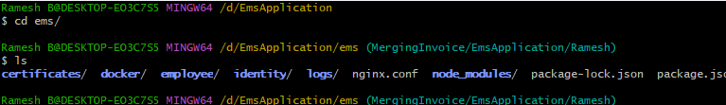
Here I use git log command
This is commits,
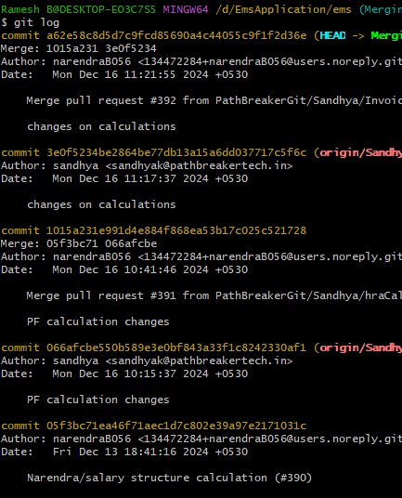

It is “Change on calculations” is commit id name,
